# A collage of different animals Description automatically generatedIntroduction about my Sri Lankan Wild Life Web Site :

S.W Aloka Kavitha De Silva.Cb-013235

Project brief

Sri Lankan Wildlife

The Sri Lankan wildlife web site include 7 pages,

Namely

1. Home page
2. Introduction
3. Conservation
4. Sri Lankan leopard
5. Animals In Sri Lanka
6. Yala park
7. Wilpattu park

## Home page

The main home page I have design it very simple this 4 navigation for other pages.

Namely,

1. Destinations
2. About us
3. Endemic animals
4. Sri Lankan leopard

Initially I add main row flex for this and divide into two columns. First column I mention my website name and some brief introduction about it. Like our widely spread biodiversity.

Then I add 4 card with including those 4 navigation pages. After that I add some images as background cover of it.

## Introduction page

In this page I want to mention our brands like, our world heritage sinharaja forest which as high biodiversity and our endemic animals which threaten because losing their habitants.

On the introduction page I have mention two navigation cards.

Namely,

* Destinations
* Our uniqueness

Regarding the destinations I mention some lists of our forests with navigation function to that part.

Regarding our uniqueness card I mention our endemic animals which are included within a table.

Considering with locations I tent to add a google location foe each forest which can get more visual for the visitor. Then I add some pictures regarding each kind of topic.

## Conservation page

* In this page I have mention our wildlife conservation department like an introduction and their responsibilities.
* This this section I have added our endemic species video that brought from YouTube Because as website visitors the usually tent to watch something rather than reading something.
* Then I create a collection of photo collages to make a clear visual appearance about how its so important.
* Then I tent to add a google map which mention about forest in srilanka.to make uplift their duty. And persuades the tourist how higher that department concern about protection of our animals and forest.
* Then I created two table with content about protected areas and protected species with a brief introduction and including an image.

## Sri Lankan leopard page

* In this page I tent to mention our endemic leopard with a description and locations that they are live.
* First add two cards for it to navigate those particular parts.
* Regarding to description I mention their behaviors, diet, habitants and also some collage about leopards and a video that describe leopard with good evidence.
* Regarding to locations part I tent to mention main two forests in Sri Lanka. with some images.
* After that I add a google map that show places where leopards are living.
* Then I added two videos about yale and willpattu to mention how leopards can find those locations.
* And I hope to arrange those content with separate sections to make more responsible page.

## Animals in Sri Lanka:

* At first I have add 3 cards in the top right conner for navigate yala park page ,willpattu page and list of animals categories. ex; mammals, birds.
* And then navigate those list for my content which has each describe of it.
* Regarding to my content first I added main topic our endemic animals then I started to categories each animals as groups ex; mammals, birds.
* In my content mainly have a common structure which one raw divide into columns.
* After that I tent to add entertainment part ex; video and collage of photos in left column.
* Then I added a navigation to collage to go to main website that I brought those things.
* Regarding to right column I tent describe some brief about mammals and birds.
* After that I mention some attractive animals with some brief introduction to make visitor some interesting feeling about it.

## Yala National park and willpattu park :

* I have still researching some good content to add my website, still I m not completed yet.
* But I apply my wireframe structure to both websites well.
* I will planning to add some brief introduction about the locations.
* And also im planning to add some animals that’s can found in those two parks with some interesting videos and images.
* Then I will planning to add accommodation side, like hotels, camping, cottages.
* Then I have an idea to mention some interesting activities that can be done on there.
* To get a good attraction with tourist I think we need to make a purpose for them so adding those kind of things may be a positive idea.

# Challengers and how overcome with it:

* At first I quiet get hard to make a dropdown menu in navigation bar which necessary for multiple choices in one button.

First I have research about some readymade websites in the internet to get a idea about the cords then I watch some you tube videos about dropdown menu. <https://www.youtube.com/watch?v=h3E68tTyE34>

Then I have remake my navigation bar to my own purpose with three buttons.

* I have face to make logo to my website:

For that I use a logo maker website to make my website.

https://logo.com/

* After that I needed to make my website nav bar responsive to mobile devices current one is to align properly in mobile version.

For that I have learn some explanations in YouTube that helps to make a responsive nav bar.

[How to Create Responsive Navigation Bar using HTML and CSS (youtube.com)](https://www.youtube.com/watch?v=oLgtucwjVII)

Then I able to make responsive navigation bar

* Regarding to first main page I needed to make it simple with some navigation.

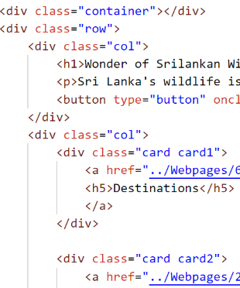

For that I make a flex with a main row a divide into two columns.

Then I tent to add the topic on left column and navigations in left.

I make some cards with same sizes and add those navigations into it.

* I need a some movement on cards that I have make.

For I use the hover function to my cards. .card:hover{

    transform: translateY(-10px);

}

* Regarding to footer I need to get some icons for the social media:

For that I went to w3school to get some icons styles. https://cdnjs.cloudflare.com/ajax/libs/font-awesome/5.15.4/css/all.min.css

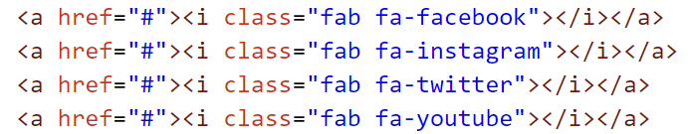Then I appy to my footer a div tag to add those links.

* I needed to add a YouTube video to my content.

That was quiet challenging for me because I have paste the link to a <p></P>but I doesn’t work

Then I started to learn something from YouTube for this issue.

<https://www.youtube.com/watch?v=ly36kn0ug4k&t=87s>

After that I able to add a video for my content.

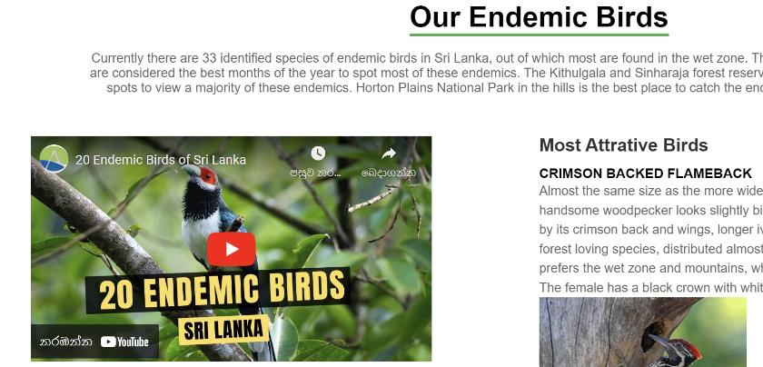

* Then I needed to add underline to main heading with green touch

For that I found a YouTube video about adding underline to those heading.

<https://www.youtube.com/watch?v=Rqo_1TV7wQs>

regarding to that I tent to add my own style for the headings.

.heading h1::after{

    content:"";

    position: absolute;

    width: 100%;

    height: 4px;

    display: block;

    margin: 0 auto;

    background-color: #4caf50;

}

* Making main source button for each content:

Honestly for build a content for my website I need to copy it by main sources that’s trustful rather than my opinion so in that case I use a button to mention the source

make it more ethical one.

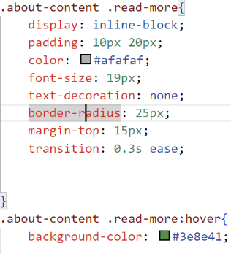Regarding to button I use some color change function after pointer.

* Mention the locations regarding to a google map:

For that I went to google map and search my location and click on

Share button and get the link as emblem one.

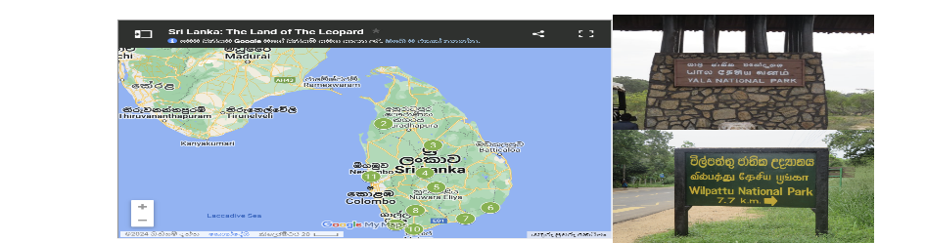

# Problems that I m still facing:

* My content is not alien to responsive mobile version

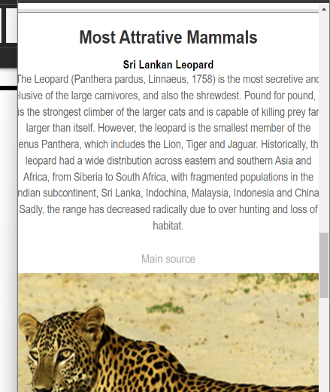

* My images are also not centering in smaller size.
* I needed to add a main photo cover for my background but when its added there are some issues about visual about my content.
* Also having issue to mention source when making collage of images.
* I’m still thinking about my color theme what is quiet suitable.